**Course Project**   
**DeVry University**   
**College of Engineering and Information Sciences**

**Course Number: CEIS101**

**Background**

The Internet of Things (IoT) is growing exponentially. New technologies and applications are being developed on a regular basis and this creates an abundance of new job opportunities each with its requisite skill sets. It is important to stay current with the skills required for this evolving job market and to take advantage of the many available learning opportunities currently available. This course project covers the fundamental concept of the IoT by integrating hardware, software, and networks into a whole system. The project is divided into six parts where each part builds upon the previous resulting in an IoT device that will simulate a smart home automation and security system. The design and development process of this project truly encompasses various aspects of the IoT and will prepare you for your future career in technology. 

**Scenario**

Develop a smart home automation and security system by designing the prototype in Tinkercad, building the hardware with the components from the IoT Tech Core Kit and programming within Arduino IDE. The smart home system will encompass various devices to monitor the condition of the home. This includes a door sensor to check whether to door is open or closed, a distance sensor to monitor for a possible home intruder, and automated lights that turn on when it is dark. Optional components can be added to the smart home system including a water level sensor to monitor for possible flooding as well as a temperature and humidity sensor to monitor the weather conditions.

**Module 3: Inventory of Parts, Circuit Building, and Displaying Messages**

**Objectives**

* To familiarize with hardware components for course project
* To learn how to build circuits with LEDs
* To learn how to program LEDs
* To learn how to initialize the Serial Monitor
* To learn how to send messages to the Serial Monitor

**Deliverables**

* Complete the Module 3 Course Project PowerPoint Deliverable
* Include a picture of IoT Tech Core Kit (5 points)
* Include a picture of components required for course project (15 points)
* Include a picture of complete circuit (10 points)
* Include a screenshot of serial monitor showing your name and messages (10 points)

**PART 1 – Inventory of Parts**

**Step 1)** Locate your IoT Tech Core Kit. Take a picture of all the items to confirm that you have all items listed in the packing this. Include this picture in your PowerPoint Deliverable. Not all the items in your kit will be used in this course. This kit will be used for other courses so treasure this kit and keep it safe.

* UCTRONICS Kit
* ESP32 microcontroller (2)
* LCD Module (2)
* Breadboard (3)
* Mini Router
* Patch Cable
* Digital Multi Meter
* USB to Micro USB cable (2)

**Step 2)** Open the UCTRONICS kit and gather the required components needed to create your smart home security system.Take a picture of all the items organized into one picture. Include this picture in your PowerPoint Deliverable.

* Arduino Mega 2560
* Breadboard
* LEDs
* Active Buzzer
* Resistor 10kΩ
* Ultrasonic Sensor
* Photoresistor
* Wires
* USB to Type B cable
* DHT-11 sensor (optional)
* Water level sensor (optional)

**PART 2 – Familiarize with components for smart home security system**

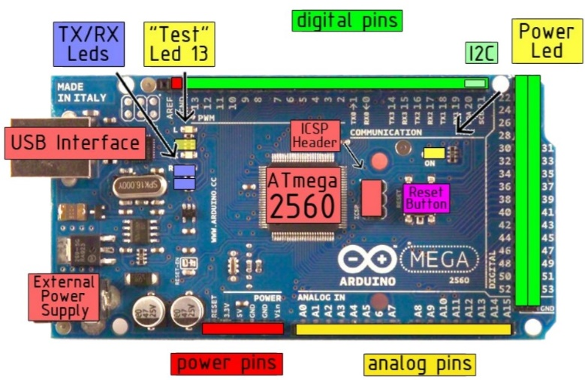*Arduino Mega 2560*

There are various microcontrollers in the Arduino family. The Arduino Mega 2560 is an extension from the Arduino UNO microcontroller and it will be used as our smart hub for the home security system. It has 54 digital input/output pins (of which 15 can be used as PWM outputs), 16 analog inputs, a USB connection, a power jack, and a reset button. The figure shown highlights the main resources and their locations on the Mega 2560.

*Breadboard*

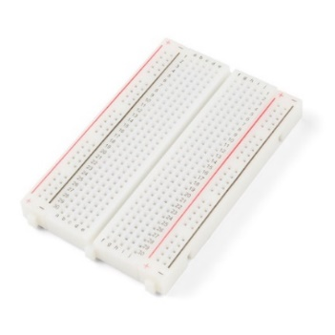Breadboards are a powerful tool for prototyping with electronics. The rows of a solderless breadboard are connected inside, allowing you to connect components by plugging them into the same row as each other. The rows are made up of sets of five metal clips. When you add a component to a breadboard, each pin of the component is typically connected to different parts of your design. Therefore, you should place each pin to be in a different row. The long rails along the edges are for easy access to power and ground. It is important to note that the power rails on either side are not connected, so if you want the same power source on both sides, you will need to connect the two sides with some jumper wires.

*LED*

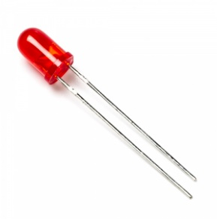The term LED stands for Light Emitting Diode. A diode is an electronics component that only lets electricity flow in one direction. This means that the LED is polarized, and it only works when the ends are connected a certain way. The longer end of the LED is the positive end and is called the anode. The other terminal of the LED is the negative end (i.e. the shorter end of the LED) and it is called the cathode. When electricity flows through the LED it converts electrical energy and outputs light. The color of the light depends on the semiconductor material it is made of.

*Active Buzzer*

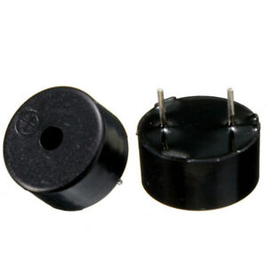A buzzer is a tiny speaker. It utilizes the concept of piezoelectricity which is an effect where certain crystals will change shape when you apply electricity to them. By applying an electric signal at a particular frequency, the crystal can output sound. Just like the LED, the buzzer is polarized, and it will only work when the ends are connected in a certain way. Your UCTRONICS kit includes both the active buzzer and passive buzzer. The active buzzer is required for the kit and you can identify it as it as a sticker on the top and a black coating on the bottom.

*Resistor (10kΩ)*

When working with LEDs you will want to use a resistor, which helps limit the current to prevent the LED from burning itself out. For just one LED you will be safe not using a resistor. 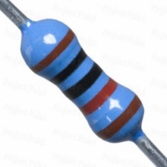The colored stripes identify the resistor’s value. Your UCTRONICS kit conveniently labels the film of resistors to quickly identify the desired resistor. The electrical resistance of a resistor is measured in ohms and is represented by the Greek letter omega: Ω. Unlike the LED, a resistor is not polarized. You can learn more about the concept of resistance in the [Tinkercad skill builder lesson on Ohm’s Law](https://www.tinkercad.com/things/0mY9lPwMIMH-ohms-law/editel?lessonid=EVDTYEEJ2UPFSL8&projectid=O2OZ3UNJ3OPN41A&collectionid=O2OZ3UNJ3OPN41A#/lesson-viewer).

*Photocell*

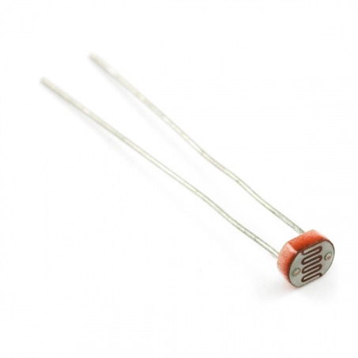The photocell, also referred to as a photoresistor or light-dependent resistor (LDR), is a two-terminal, resistive component that increases or decreases its resistance depending on the light it senses. As more light shines of the sensor’s head, the resistance between its two terminals decreases. By combining the photocell with a resistor, we can create a voltage divider that produces a voltage dependent on the photocell's resistance. The Arduino can then read the variable voltage through the analog to digital converter.

*Ultrasonic Distance Sensor HC-SR04*

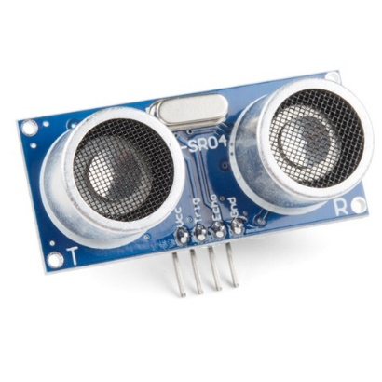The ultrasonic sensor is an electronic device with two transducers that are used to detect an object within its range. The range of the sensor is from 3 cm to 3 m. When activated, one transducer sends a burst of ultrasounds by converting electric pulses into sound waves emitting them with frequency 40 kHz above the human hearing threshold. The other transducer other listens for the echo of the ultrasounds to bounce off an obstacle and come back. The sensor measures the round-trip time between the outburst of ultrasound and the reception of the echo. With the known round-trip times and speed of sound, the ultrasonic device can measure the distance that the sound traveled. We will use the ultrasonic distance sensor that has pins. The VCC pin is the operating voltage pin and the GND pin is the ground pin. The Trig pin is used to output the burst of ultrasounds and the Echo pin is used to read the returning echo from a nearby obstacle. The pins and technique described is illustrated in the figure below:

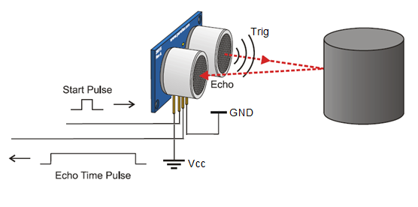

**PART 3 – Building circuits and displaying messages to Serial Monitor**

**Step 1)** Now that you have simulated how to make an LED blink in Tinkercad, it’s time to try it in a real system! Referencing the schematic below the circuit below, connect a red LED to the breadboard. The longer lead of the LED connects to pin 2 on the Arduino Mega 2560 and the shorter lead of the LED connects to the GND (-) rail of the breadboard.

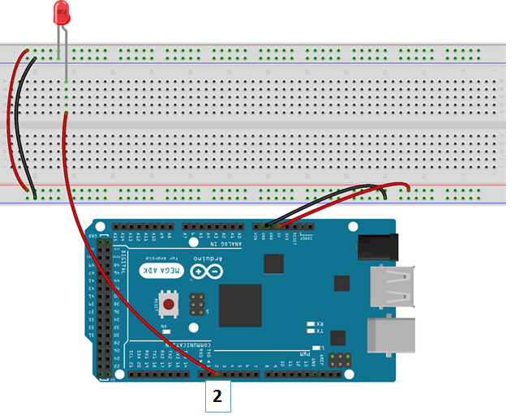

**Step 2)** Open Arduino IDE, erase all the contents in the sketch and replace it with the code shown below. Be sure you have the correct board and port selected in the Tools menu. Upload the code to the Arduino Mega Board and run it. You will be prompted to save the sketch.

#define Rled 2 // Set up variable for Red LED as pin 2

void setup() {

pinMode(Rled, OUTPUT); //Set up Rled (pin 2) as output

}

void loop() {

digitalWrite(Rled, HIGH); // Turn ON the Red LED

delay(**1000**); //delay 1000 millisec= 1 second

digitalWrite(Rled, LOW); // Turn OFF the Red LED

delay(**1000**); //delay 1000 millisec= 1 second

}

**Step 3)** Try changing the delay amount from 1000 to 100 and re-run the sketch. Notice how the blinking changes. Take a picture your complete circuit when the LED is on. Include this picture in your PowerPoint Deliverable.

**Step 4)** Now let’s send messages from the Arduino Mega Board to the computer. The Serial Monitor is separate pop-up window within Arduino IDE that is used to send and receive data from the microprocessor. For the Arduino to be able to send messages, it needs to establish a new communication channel with Serial.begin() inside the setup() function. The number inside the Serial.begin parenthesis is called an argument and it tells the Arduino how fast to communicate the messages. In this case, the baud rate is 9600 bits per second. Inside the loop() function the Serial.println() sends the data to the monitor over the USB cable.

Copy and paste the program below in a new sketch. Replace the **xxxxx** with your name. Upload the program to the Arduino Mega and run it.

#define Rled 2 // Set up variable for Red LED as pin 2

void setup() {

Serial.begin(9600); // Sets the baud rate for logging

pinMode(Rled, OUTPUT); //Set up Rled (pin 2) as output

Serial.println("CEIS101 Course Project Module 3");

Serial.println("Name: **xxxxx** "); //**replace xxxxx with your name**

}

void loop() {

digitalWrite(Rled, HIGH); // Turn ON the Red LED

Serial.println("Red LED is ON");

delay(1000);//delay 1000 msec= 1 second

digitalWrite(Rled, LOW); // Turn OFF the Red LED

Serial.println("Red LED is OFF");

delay(1000); //delay 1000 msec= 1 second

}

To view the messages sent to the serial monitor, open the Serial Monitor by going to Tools-> Serial Monitor.

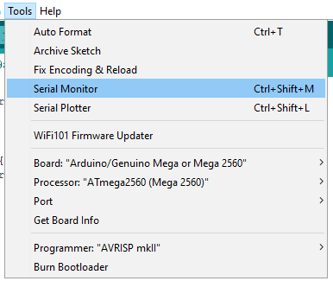

Confirm in the serial monitor at the bottom right that the baud rate matches the number in the setup function.

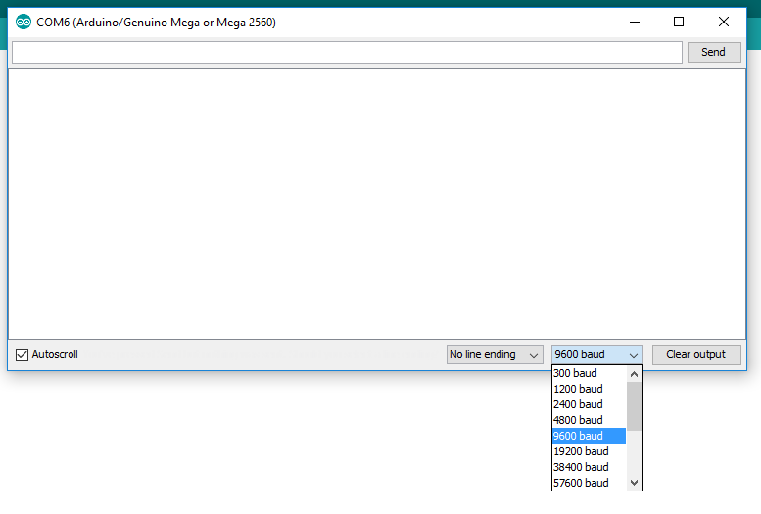

**Step 5)** Take a screenshot of the Serial Monitor such that your name is displayed, and the messages that the LED is on/off are shown. Include this picture in your PowerPoint Deliverable.

**Step 6)** Submit the PowerPoint Deliverable.